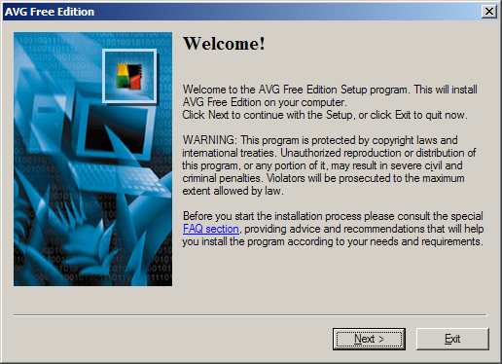
First things first... install anti-virus software!

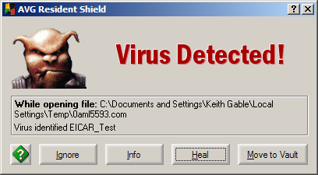
Whammo!

Summary
This lab didn't teach me anything other than AVG actually does have a working resident scanner. I always thought that it wasn't exactly immediate, but it was resident. But it caught this sucker so fast that Firefox thought that I had a disk read/write error. Also, this lab reminded me to install AVG on my new Windows install. It should have been one of the first things I did, but it wasn't. I don't have any viruses or anything (I stay away from things like that). But, future prevention is the best thing :).

